|  |
| --- |
| Name: |
| Student Reference Number: |



|  |  |  |
| --- | --- | --- |
| Module Code: | Module Name: | |
| Coursework Title: | | |
| Deadline Date: | | Member of staff responsible for coursework: |
| Programme: | | |
| Please note that University Academic Regulations are available under Rules and Regulations on the University website [www.plymouth.ac.uk/studenthandbook](http://www.plymouth.ac.uk/studenthandbook). | | |
| Group work: please list all names of all participants formally associated with this work and state whether the work was undertaken alone or as part of a team. Please note you may be required to identify individual responsibility for component parts.  ***We confirm that we have read and understood the Plymouth University regulations relating to Assessment Offences and that we are aware of the possible penalties for any breach of these regulations. We confirm that this is the independent work of the group.***  Signed on behalf of the group: | | |
| Individual assignment: ***I confirm that I have read and understood the Plymouth University regulations relating to Assessment Offences and that I am aware of the possible penalties for any breach of these regulations. I confirm that this is my own independent work.***  Signed : | | |
| Use of translation software: failure to declare that translation software or a similar writing aid has been used will be treated as an assessment offence.  I *have used/not used translation software.  If used, please state name of software………………………………………………………………… | | |
| **Overall mark _____% Assessors Initials ______ Date_________** | | |

*Please delete as appropriateSci/ps/d:/students/cwkfrontcover/2013/14

Haritha Rathnayake

[Draw your reader in with an engaging abstract. It is typically a short summary of the document. When you’re ready to add your content, just click here and start typing.]

Driver Rescue System

Technical Specification Document

Contents

Table of Figure 0

Chapter 02 1

Requirement Gathering Techniques 1

Existing system 1

Diagrams 2

Entity Relation Diagrams 2

Use Case Diagrams 3

High Level Architecture Diagram 3

# Table of Figure

Figure 2.1(ER Diagram for Facial Recognition system) 2

Figure 2.2(Use Case Diagram for DRS) 3

Figure 2.3(High Level Architecture Diagram) 3

Figure 3.1(MPU6050 Module) 5

Figure 3.2(GPU Module) 6

# Chapter 02

## Requirement Gathering Techniques

In this project our target is to provide a solution for one specific type of user. There won’t be any unintended users. So, we need to get a very good understanding about the requirement. To understand these requirements, we need to work in the targeted environment. In this case, they are drivers’ perspectives, hospitals and polices. We can learn about how often and what kind of situation they have being experienced. Depend on those experiences we can build the solution for the most efficient way possible.

For the system we need to access Internet through a cellular network as the provide GPS support as well. The system requires ability to call and track the vehicle. Most of the modern vehicles seems to have inbuild cellular network for various purpose. So we can access this network to implement the system. But we need to figure out, how to call a near by emergency service via cellular network. For this we may need industry support.

The final goal of this project is to provide the prototype of our solution. This is an excellent way to share or present ideas to the user. So, we can demonstrate the prototype to stakeholders and improve the solution more before the implementation.

For the final implementation we need to choose an optimal position to place the system in the vehicle. So wee need support from industry level team to discuss about vehicle third party installations.

### Existing system

Talking about existing systems for our solution, currently there only driver’s safety systems to monitor the driver’s health, but not a system of solution for an after accident. In modern cities there are many surveillance systems to monitor, but in case the accident takes place in a place that those system are do not exists, these existing systems are not perfect. In our solution, the system always monitors the vehicle momentum and triggers the system if unusual momentum happens. This will increase the chance of survival of the victim more than any other existing system.

## Diagrams

### Entity Relation Diagrams

**\*\*Note that, the following figure(2.1) is an ER of an optional feature of the system. May not include in the final release\*\***

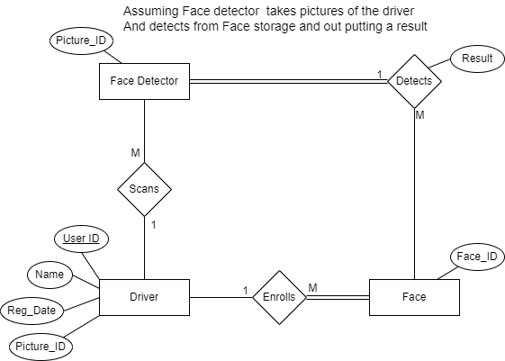

Figure 2.1(ER Diagram for Facial Recognition system)

### Use Case Diagrams

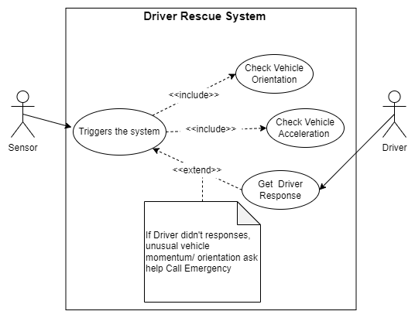

Figure 2.2(Use Case Diagram for DRS)

## High Level Architecture Diagram

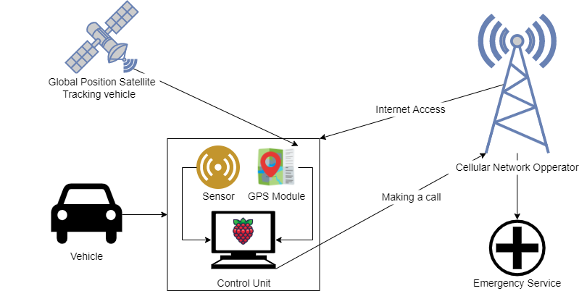

Figure 2.3(High Level Architecture Diagram)

## Chapter Summery

In this chapter we have discussed about the basic requirements for this system. The final goal is to build a more efficient and reliable solution that the existing solution. The final product will be a full functioning prototype, but it will be enough for demonstration and presenting to the stockholders. We may seek some industry level guides to implement some key points of the system.

The diagram figures in this chapter shows how the full system is divided.

# Chapter 3

## Hardware

### MPU 6050

Currently, widespread microelectromechanical systems (MEMS). This was made possible due to their small size, high functionality, high reliability, low power consumption and low cost. Typical examples of MEMS are accelerometers and gyroscopes, which are in every Smartphone, tablet computer, etc. The former are used to measure linear accelerations, and the latter, angular velocities. The combined use of the accelerometer and gyroscope allows you to determine the movement of the body in three-dimensional space(Fedorov et al. no date).

With these measurements we can use this sensor for our system. This sensor will update the system with linear acceleration and orientation and detect any kind of accidents. The control unit will identify any sudden change of the velocity, acceleration and unusual orientation then triggers the system.

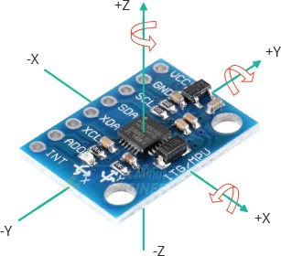

Figure 3.1(MPU6050 Module)

For an example, a vehicle hitting head to head with another vehicle means, the velocity and acceleration will drop within a second. The control unit will identify the difference and produce to the next step. In case of the vehicle flipped, the sensor can measure that to. So, the CU will identify any unusual positioning of the vehicle and triggers the system.

### NEO6MV2 GPS module

This module is an optional device that we have planned to use in case the vehicle we are going to implement this system does not have any cellular network.

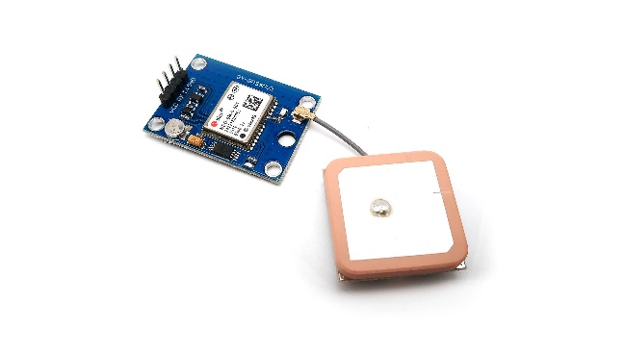

Figure 3.(GPU Module)

# References

Fedorov, D.S., Ivoylov, A.Y., Zhmud, V.A. & Trubin, V.G., no date, *Using of Measuring System MPU6050 for the Determination of the Angular Velocities and Linear Accelerations*.